M

Position details

Division: Lord Mayor’s Office
Branch: Lord Mayor’s Office
Reports to title: EA to the Lord Mayor
Position No: 84833
Classification: Class 4
Financial Management: Nil
Total People: Nil

Primary skill pool: Administration
Secondary skill pool: Finance and accounting

Team context

The Lord Mayor is the leader of the Council, chairs Council meetings and represents the City of Melbourne at significant government, business and community meetings and forums, and acts as the ceremonial head of the city at important civic events.
The Lord Mayor regularly represents the Council in the media as the primary spokesperson and advocate for the City of Melbourne.
The Lord Mayor’s Office provides high level strategic, policy and administrative support services to the Lord Mayor and Deputy Lord Mayor.
Staff within the Lord Mayor’s office work closely with the offices of the Chief Executive Officer, Councillor Support, General Managers and Directors to ensure an effective relationship exists to support the efficient and effective operations of Council.
The Lord Mayor’s Office is within the Executive Services Division. The Division provides high-level strategic and operational support to the Chief Executive Officer, Lord Mayor, Deputy Lord Mayor and Councillors.

Culture and Values

CoM aspires to a culture which is humanistic and encouraging, self-actualising, affiliative and achievement focused. We focus on culture because we know that a constructive culture is good for our wellbeing as well as our ability to deliver high quality outcomes.

We measure our performance against the desired culture using the Human Synergistics tool, the “Organisational Culture Inventory” (OCI).
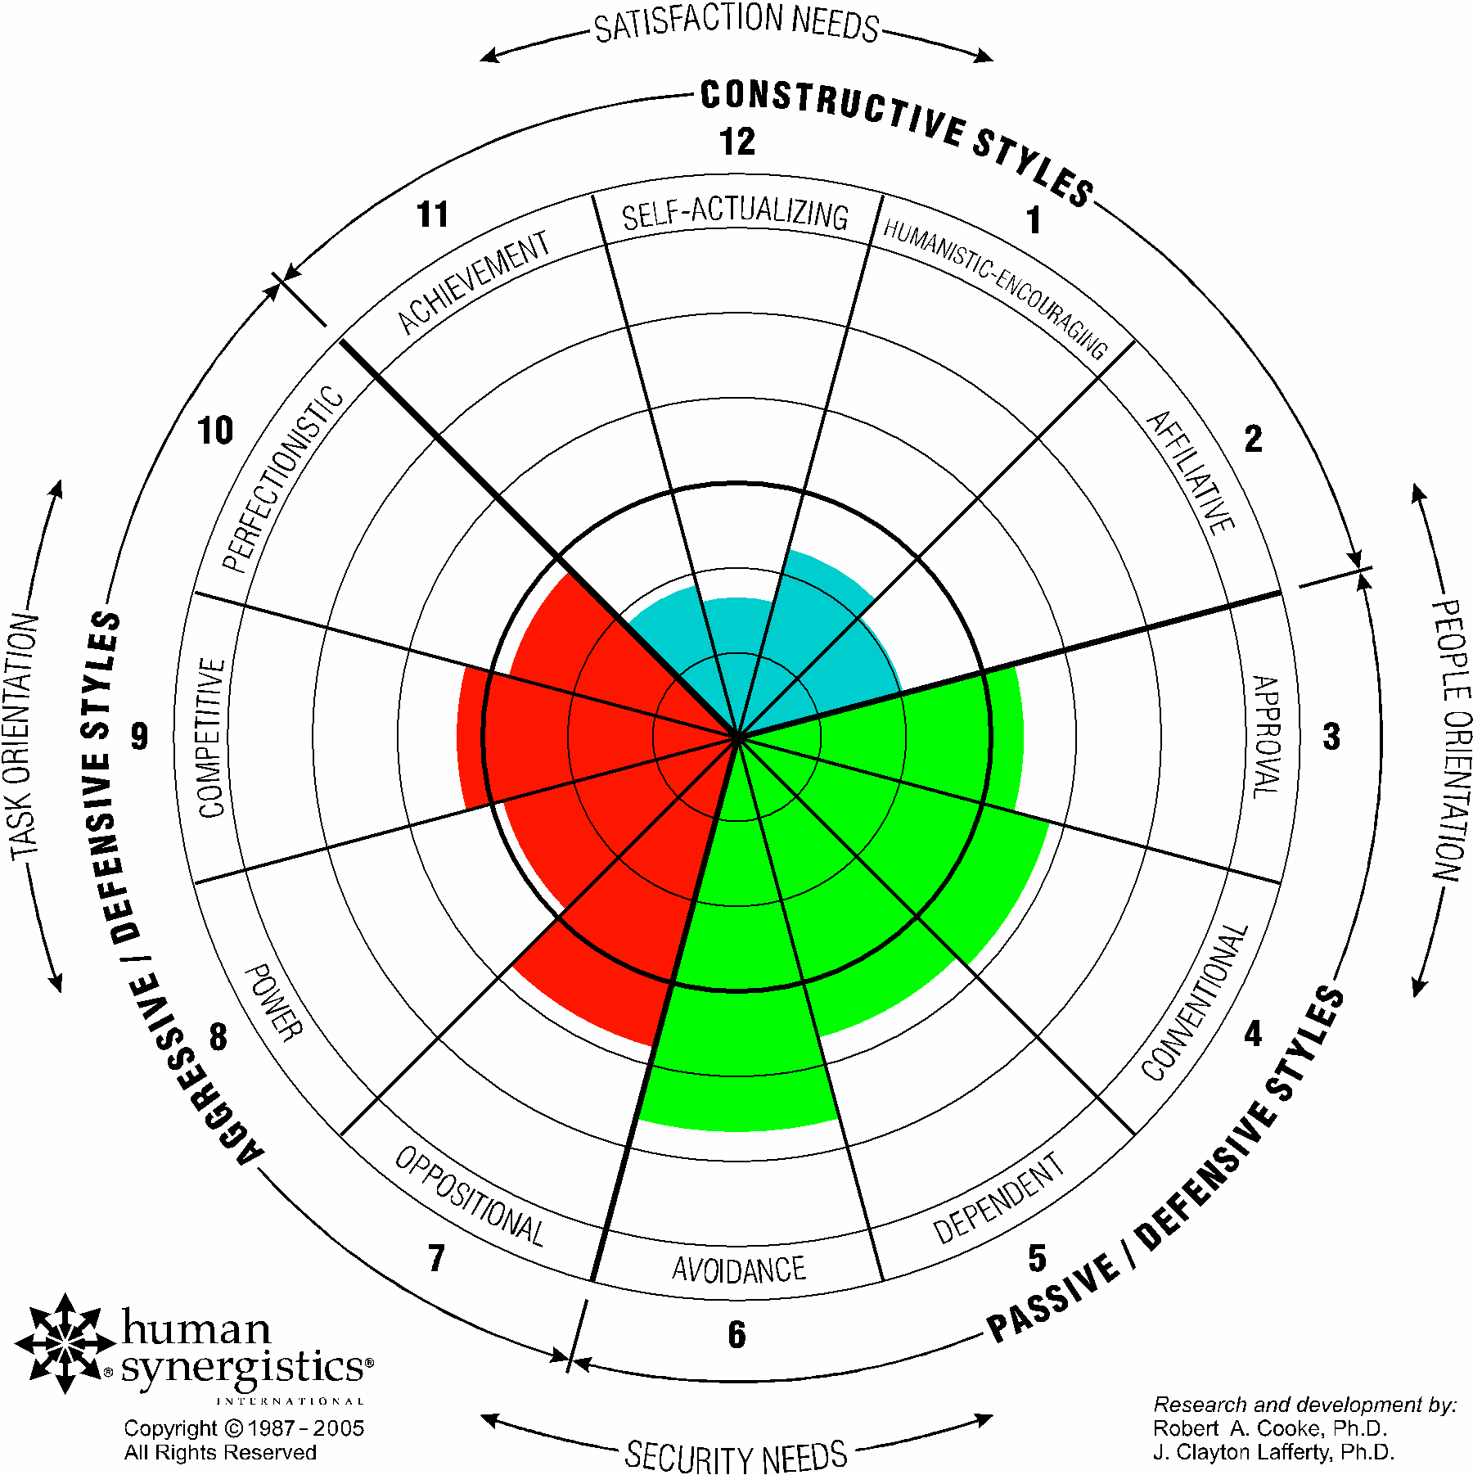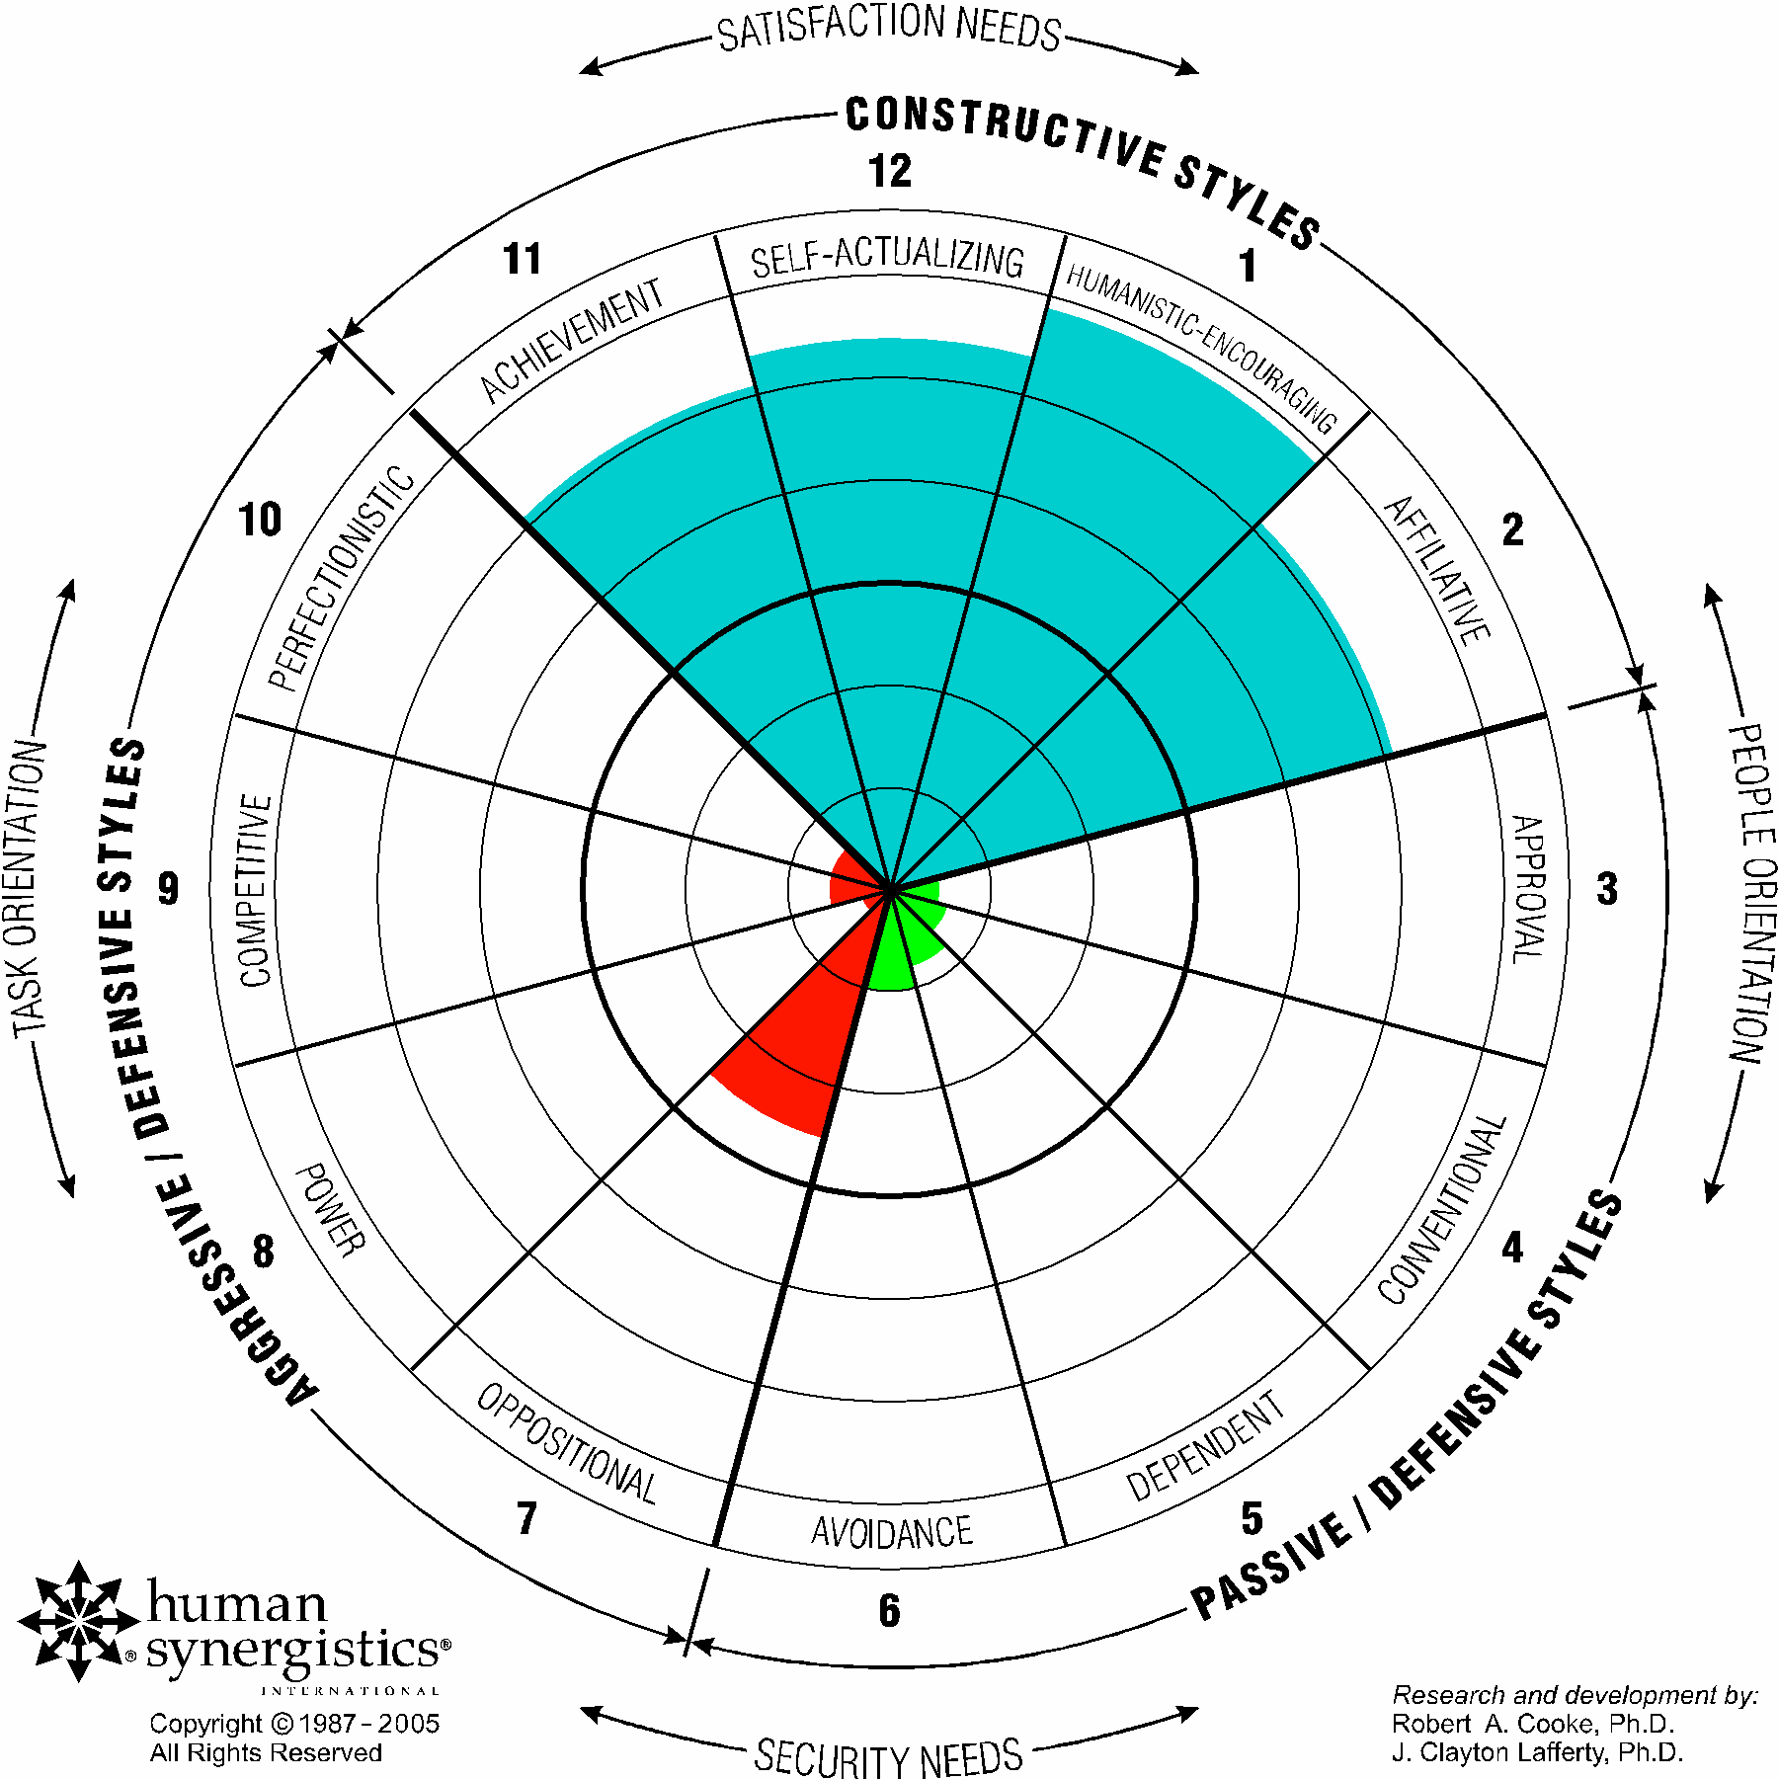

Our ICARE values (integrity, courage, accountability, respect and excellence) are the foundation for our behaviour for ourselves and our teams.
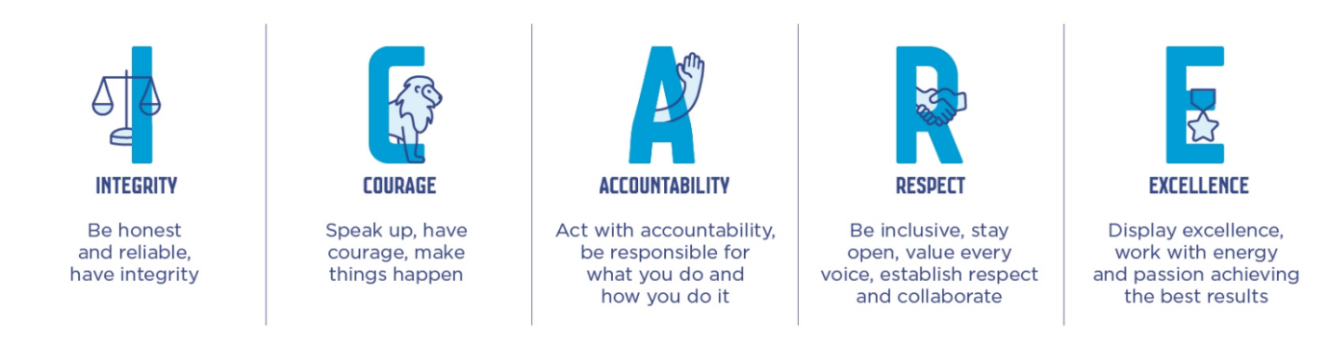

Position purpose

The Business Support Officer, Lord Mayor’s Office provides high-quality administrative and business support to ensure the efficient operation of the Office and the effective delivery of the Lord Mayor’s priorities and engagements. The role supports day-to-day office management, financial administration, correspondence coordination, and scheduling activities, while maintaining professionalism, confidentiality, and attention to detail in all interactions.

Position accountabilities

- Provide high-quality administrative and business support to ensure the smooth daily operation of the Lord Mayor’s Office, maintaining an organised and professional workspace each day.

- Assist in the management of the Lord Mayor’s calendar, meetings, civic engagements, and internal/external appointments, ensuring accuracy, timeliness, and alignment with organisational priorities.

- Organise meeting logistics, including notifying Security of guests, and manage meeting catering.

- Manage the high-volume invitations spreadsheet (up to 50+ at a time), tracking acknowledgements, actioning declines and representation requests.

- Undertake financial and office administration, including processing invoices, raising purchase orders, managing accounts and supporting the monitoring of budgets in line with council procedures).

- Manage stationery orders and maintain adequate stock levels to support the efficient functioning of the office.

- Assist with Lord Mayor’s office Salesforce tracking when needed.

- Demonstrate strong technical capability by quickly learning new systems and providing basic IT support to the Lord Mayor and Chief of Staff as required.

- Maintain office systems, digital filing, and administrative processes to ensure streamlined workflow and accurate record keeping.

- Coordinate travel bookings, itineraries, and related arrangements for the Lord Mayor and senior staff.

- Support the delivery of ad hoc projects and priority tasks as directed, ensuring timely and professional outcomes.

- Liaise effectively with internal teams, Councillors’ offices, and external stakeholders, handling sensitive matters with discretion, confidentiality, and sound judgement.

- Provide operational and administrative support to the Executive Assistant to the Lord Mayor to ensure seamless coordination of office priorities.

- Maintain full on-site presence (five days per week) to meet the demands of a high-profile executive environment and support time-critical activities.

Environment: communication and judgment

Communication:
The Business Support Officer is required to deal with a variety of internal and external parties on behalf of Creative City. Highly proficient communication skills (verbal and written), are critical for the performance of the role to effectively manage business needs and impart and acquire information across and from a range of people within the team, across the branch, and key stakeholders (internal and external).

The position works collaboratively with other team members in providing a coordinated approach to business support and requires an open communication style to effectively support others in a continuous improvement environment.

Judgment:
The Business Support Officer independently plans and manages position outputs and makes decisions relating to the day to day business administration of the team within the scope of the position responsibilities and parameters of CoM policy and processes. Any non-routine or more complex matters are escalated for a decision. A high level of initiative is required to independently plan and manage these position outputs, along with a pro-active and ‘can-do’ attitude.

The role requires the ability to refer to a range of information quickly to complete a variety of work tasks at any one time. The incumbent will need to provide direction to others whilst maintaining a flexible and resourceful approach within a fast-paced and high pressure environment, maintaining service delivery excellence.

Selection criteria

All CoM employees will demonstrate an ability to articulate and demonstrate benefits of positive culture and values.

In addition, the position will require:
- A relevant Tertiary Qualification and/ or minimum 2 years related industry experience.
- Experience in a business support delivery function with the ability to anticipate support needs within a fast-paced, high volume and multi-faceted business environment.
- Demonstrated skills in financial management including budget tracking, invoicing, purchase requisition.
- Sound communication and interpersonal skills with the ability to communicate and liaise confidently at all levels of the business.
- Highly developed customer service skills and demonstrated ability to be professional, assertive, and courteous, with the ability to maintain confidentiality.
- Ability to work independently and collaboratively within a team environment supporting productive relationships with people at all levels.
- A pro-active approach applying initiative to independently manage workflow and apply judgment in making decisions with limited direction for routine matters.
- Sound technology experience across the full MS Office suite especially in the preparation of Word, PowerPoint, Sharepoint and Excel documents that are accurate and fit for business purpose.
- Ability to contribute to systems and processes development to drive efficiency across administrative functions within a continuous improvement environment.

Inherent Physical Requirements

The reference to the Inherent Physical Requirements for this position is DM# 9233657.

The way we work

Commitment to Child Safety
The City of Melbourne (CoM) is committed to being a child safe organisation and has zero tolerance for child abuse. All children and young people are valued members of our community and have the right to be and feel safe. We are committed to embedding child safety into the everyday thinking and practice of all employees, agency staff, contractors and volunteers. We require all CoM employees, agency staff, volunteers and contractors to understand and act to prevent, detect, respond and report any suspicion of child abuse and maintain a culture of child safety and any further responsibilities as required by the role.

Our leaders are core to realising our vision of a leading organisation for a leading city. CoM leaders drive a workplace that is stimulating, constructive, flexible, diverse and inclusive and enables achievement of high-quality outcomes for the Council, customers and our community. We recognise that a constructive culture brings out the best in our people. We strive to meet the demands of our employees’ professional lives while they can accomplish their priorities outside of work and have a positive work life balance.

Our leaders strive to make our organisation agile, with the ability for our work teams to adapt and change based on the evolving needs of CoM. To keep pace with our customers and our changing city, we need a resilient, adaptable, accountable, diverse and inclusive workforce that reflects our community and is committed to excellence.

We establish challenging but realistic goals, develop plans to reach those goals, pursue them with enthusiasm, and are accountable for their achievement. We want our employees to get enjoyment from their work, develop themselves, and take on new and interesting activities whether they are within CoM or outside of CoM. We want our workforce to be supportive, helpful and open in their dealings with each other, through open communication, cooperation, and the effective coordination of activities.

